Global Educate Foundation’s

Global College of Commerce, Hubli.

BCA . VI th Semester Result Analysis April 2018

- Subject Wise Report

SL No | Subject | Attendance Report |  |  | Result
SL No | Subject | Present | Absent | Total | Pass | Fail | Total | Percentage  of Passing
01 | Computer Graphics F21 | 68 | 00 | 68 | 65 | 03 | 68 | 95.58
02 | E Commerce F22 | 68 | 00 | 68 | 64 | 04 | 68 | 94.11
03 | Introduction to Unix F23 | 68 | 00 | 68 | 55 | 13 | 68 | 80.88
04 | Object Oriented Sys Design F24 | 68 | 00 | 68 | 56 | 12 | 68 | 82.35
05 | Computer Network F25 | 68 | 00 | 68 | 61 | 07 | 68 | 89.70
06 | Project / Viva-Voce F31 | 67 | 01 | 68 | 66 | 0 | 67 | 100
07 | Over All | 68 | 01 | 68 | 50 | 18 | 68 | 74

II) Grade Wise Report

Sl No | Result | No of Students | Percentage
1 | Distinction | 39 | 57.35
2 | First class | 11 | 16.17
3 | Second Class | 00 | 00
4 | Fail | 18 | 26.47
5 | Total Students | 68

III ) Pie Chart

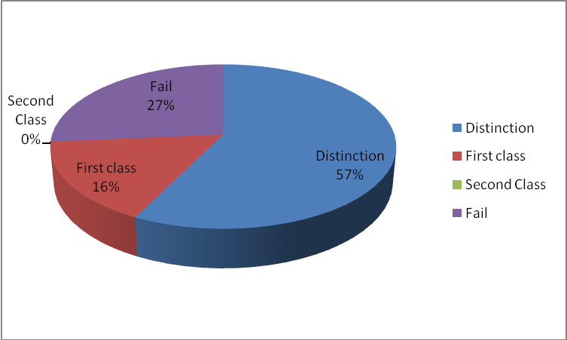

IV) Top 10 Students

Sl. NO | University No | Name | Total  (Out of 800) | Percentage
1 | 15U10711 | Arpita.Manoj.Chikkodi | 736 | 92.00
2 | 15U10716 | Blessy..Ekbote | 685 | 85.62
3 | 15U10754 | Sonal.U.Solanki | 684 | 85.50
4 | 15U10755 | Soniya..Trivedi | 683 | 85.375
5 | 15U10709 | Apporva..Madhusudan | 679 | 84.875
6 | 15U10704 | Allamaprabhu.M.Muchakhandimath | 671 | 83.875
7 | 15U10708 | Annapoorna.K.Madiwalar | 663 | 82.875
8 | 15U10764 | Shwetha..Reddy | 655 | 81.875
9 | 15U10722 | Harshitha B M.. | 653 | 81.625
10 | 15U10753 | Snehitkumar..Hiremath | 649 | 81.125

Principal
Global College, Hubli.

